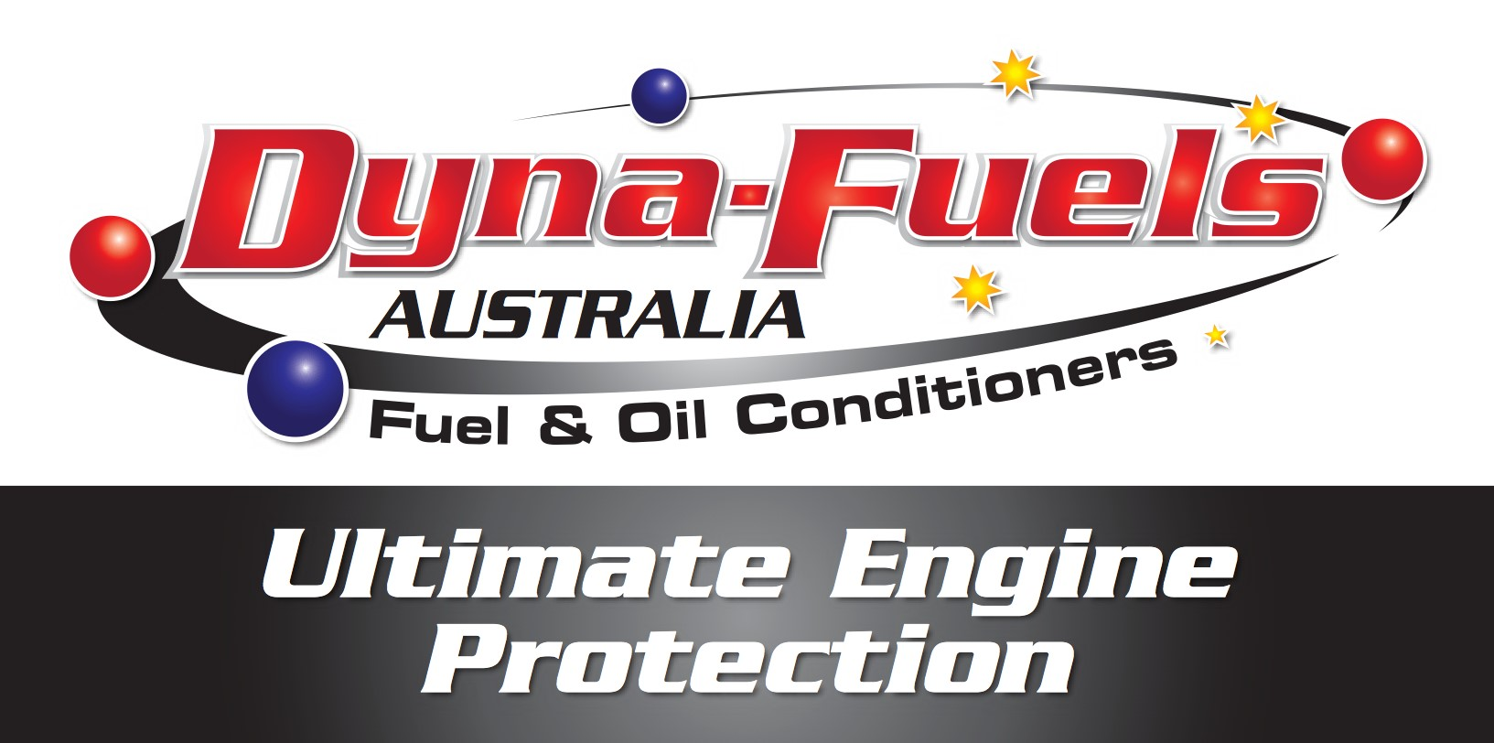

Product Name Diesel System Cleaner

1. IDENTIFICATION OF THE MATERIAL AND SUPPLIER
Supplier Name  Address  Telephone  Fax  Emergency  Web Site  Synonym(s)  Use(s)  SDS Date | Dyna Fuels Australia Pty Ltd  94/38-40 Popes Road Keysborough 3173  (03) 97080023  0405749145  DF - PRODUCT CODE  FUEL ADDITIVE • HYDROCARBON FUEL ADDITIVE  19 Oct 2017

2. HAZARDS IDENTIFICATION

NOT CLASSIFIED AS HAZARDOUS ACCORDING TO SAFE WORK AUSTRALIA CRITERIA

NOT CLASSIFIED AS A DANGEROUS GOOD BY THE CRITERIA OF THE ADG CODE
UN No. None Allocated  Packing Group None Allocated |  | DG Class  Hazchem Code |  | None Allocated  None Allocated | Subsidiary Risk(s) |  | None Allocated
3. COMPOSITION/ INFORMATION ON INGREDIENTS
 | Ingredient |  | Formula |  |  | CAS No. |  | Content
 | ETHOXYLATED FATTY ALCOHOL SURFACTANT |  | Not Available |  |  | 68131-39-5 |  | >30%
 | DIETHYLENE GLYCOL MONOBUTYL ETHER |  | C8-H18-O3 |  |  | 112-34-5 |  | <20%
 | ANIONIC DETERGENT(S) |  | Not Available |  |  | Not Available |  | <40%

4. FIRST AID MEASURES

Eye | If in eyes, hold eyelids apart and flush continuously with running water. Continue flushing until advised to stop by a Poisons Information Centre, a doctor, or for at least 15 minutes.
Inhalation  Skin | If inhaled, remove from contaminated area. Apply artificial respiration if not breathing.  If skin or hair contact occurs, remove contaminated clothing and flush skin and hair with running water.
Ingestion | For advice, contact a Poison Information Centre on 13 11 26 (Australia Wide) or a doctor (at once).
Advice to Doctor Treat symptomatically.

5. FIRE FIGHTING MEASURES

Flammability  Fire and  Explosion  Extinguishing | Combustible. May evolve toxic gases (carbon oxides, hydrocarbons) when heated to decomposition.  Evacuate area and contact emergency services. Toxic gases may be evolved in a fire situation. Remain upwind and notify those downwind of hazard. Wear full protective equipment including Self Contained Breathing Apparatus (SCBA) when combating fire. Use waterfog to cool intact containers and nearby storage areas.  Dry agent, carbon dioxide, foam or water fog. Prevent contamination of drains or waterways.
Hazchem Code | None Allocated
Page 1 of 4

Reviewed: 19 Oct 2018
Printed: 19 Oct 2018

Product Name Diesel System Cleaner

6. ACCIDENTAL RELEASE MEASURES

Spillage If spilt (bulk), use personal protective equipment. Contain spillage, then cover / absorb spill with non-combustible absorbant material (vermiculite, sand, or similar), collect and place in suitable containers for disposal. Prevent spill entering drains or waterways. CAUTION: Spill site may be slippery.

7. STORAGE AND HANDLING

Storage Handling | Store in a cool, dry, well ventilated area, removed from oxidising agents, acids, heat or ignition sources and foodstuffs. Ensure containers are adequately labelled, protected from physical damage and sealed when not in use. Large storage areas should have appropriate ventilation systems. Store as a Class C1 Combustible Liquid (AS1940).  Before use carefully read the product label. Use of safe work practices are recommended to avoid eye or skin contact and inhalation. Observe good personal hygiene, including washing hands before eating. Prohibit eating, drinking and smoking in contaminated areas.

8. EXPOSURE CONTROLS/ PERSONAL PROTECTION
Exposure Stds No exposure standard(s) allocated.
Biological Limits No biological limit allocated.
Engineering Avoid inhalation. Use in well ventilated areas. Controls
PPE Wear splash-proof goggles and rubber or PVC gloves. When using large quantities or where heavy contamination is likely, wear: coveralls. Where an inhalation risk exists, wear: a Type A (Organic vapour) respirator.
9. PHYSICAL AND CHEMICAL PROPERTIES
Appearance | CLEAR COLOURED LIQUID | Solubility (water) | SOLUBLE
Odour | SLIGHT ODOUR | Specific Gravity | 0.95 - 1.05
pH | 7 (Approximately) | % Volatiles | 10 %
Vapour Pressure | 2 mm Hg @ 20°C | Flammability | CLASS C1 COMBUSTIBLE
Vapour Density | NOT AVAILABLE | Flash Point | > 75°C (cc)
Boiling Point | > 120°C | Upper Explosion Limit | NOT AVAILABLE
Melting Point | NOT AVAILABLE | Lower Explosion Limit | NOT AVAILABLE
Evaporation Rate | NOT AVAILABLE
10. STABILITY AND REACTIVITY
Chemical Stability  Conditions to Avoid  Material to Avoid  Hazardous  Decomposition  Products  Hazardous Reactions | Stable under recommended conditions of storage.  Avoid heat, sparks, open flames and other ignition sources.  Incompatible with oxidising agents (eg. hypochlorites), acids (eg. nitric acid), heat and ignition sources.  May evolve toxic gases (carbon oxides, hydrocarbons) when heated to decomposition.  Polymerization is not expected to occur.  Page 2 of 4  Reviewed: 19 Oct 2018  Printed: 19 Oct 2018

Product Name Diesel System Cleaner

11. TOXICOLOGICAL INFORMATION

Health Hazard  Summary | Low toxicity - irritant. Use safe work practices to avoid eye or skin contact and inhalation. Over exposure may result in irritation.
Eye | Irritant. Contact may result in irritation, lacrimation, pain and redness.
Inhalation | Low irritant. Over exposure may result in irritation of the nose and throat, with coughing. Due to the low vapour pressure, an inhalation hazard is not anticipated with normal use.
Skin | Irritant. Contact may result in drying and defatting of the skin, rash and dermatitis.
Ingestion | Low toxicity. Ingestion of large quantities may result in nausea, vomiting and gastrointestinal irritation.
Toxicity Data | DIETHYLENE GLYCOL MONOBUTYL ETHER (112-34-5)  LD50 (Ingestion): 4500 mg/kg (rat)  LD50 (Intraperitoneal): 850 mg/kg (mouse)  LD50 (Skin): 2700 mg/kg (rabbit)

12. ECOLOGICAL INFORMATION

Environment Limited ecotoxicity data was available for this product at the time this report was prepared. Ensure appropriate measures are taken to prevent this product from entering the environment.

13. DISPOSAL CONSIDERATIONS

Waste Disposal For small amounts, absorb with sand, vermiculite or similar and dispose of to an approved landfill site. For larger amounts, contact the manufacturer for additional information. Prevent contamination of drains or waterways as aquatic life may be threatened and environmental damage may result.
Legislation Dispose of in accordance with relevant local legislation.
14
. TRANSPORT INFORMATION

NOT CLASSIFIED AS A DANGEROUS GOOD BY THE CRITERIA OF THE ADG CODE
Shipping Name UN No.  Packing Group | None Allocated None Allocated None Allocated | DG Class  Hazchem Code | None Allocated  None Allocated | Subsidiary Risk(s) | None Allocated
15
. REGULATORY INFORMATION
Poison Schedule A poison schedule number has not been allocated to this product using the criteria in the Standard for the Uniform Scheduling of Drugs and Poisons (SUSDP).
AICS All chemicals listed on the Australian Inventory of Chemical Substances (AICS).

16. OTHER INFORMATION

Additional ABBREVIATIONS:
Information ACGIH - American Conference of Industrial Hygienists.
ADG - Australian Dangerous Goods.
BEI - Biological Exposure Indice(s).
CAS# - Chemical Abstract Service number - used to uniquely identify chemical compounds.
CNS - Central Nervous System.
EC No - European Community Number.
HSNO - Hazardous Substances and New Organisms.
IARC - International Agency for Research on Cancer.
mg/m3 - Milligrams per Cubic Metre.
NOS - Not Otherwise Specified.
pH - relates to hydrogen ion concentration using a scale of 0 (high acidic) to 14 (highly alkaline).
ppm - Parts Per Million.
RTECS - Registry of Toxic Effects of Chemical Substances.
STEL - Short Term Exposure Limit.
SWA - Safe Work Australia.
TWA - Time Weighted Average.
HEALTH EFFECTS FROM EXPOSURE:
It should be noted that the effects from exposure to this product will depend on several factors including: frequency and duration of use; quantity used; effectiveness of control measures; protective equipment used and method of application. Given that it is impractical to prepare a Chem Alert report which would encompass all possible
Page 3 of 4

Reviewed: 19 Oct 2018
Printed: 19 Oct 2018
!
!
Product Name  Report Status | Diesel System Cleaner  scenarios, it is anticipated that users will assess the risks and apply control methods where appropriate.  PERSONAL PROTECTIVE EQUIPMENT GUIDELINES:  The recommendation for protective equipment contained within this Chem Alert report is provided as a guide only. Factors such as method of application, working environment, quantity used, product concentration and the availability of engineering controls should be considered before final selection of personal protective equipment is made.  This document has been compiled by RMT on behalf of the manufacturer of the product and serves as the manufacturer's Safety Data Sheet ('SDS').  It is based on information concerning the product which has been provided to RMT by the manufacturer or obtained from third party sources and is believed to represent the current state of knowledge as to the appropriate safety and handling precautions for the product at the time of issue. Further clarification regarding any aspect of the product should be obtained directly from the manufacturer.  While RMT has taken all due care to include accurate and up-to-date information in this SDS, it does not provide any warranty as to accuracy or completeness. As far as lawfully possible, RMT accepts no liability for any loss, injury or damage (including consequential loss) which may be suffered or incurred by any person as a consequence of their reliance on the information contained in this SDS.  SDS Date19 Oct 2018  End of Report
Page 4 of 4
RMT
Reviewed: 19 Oct 2018
Printed: 19 Oct 2018

